What happened to the Lake on Titan?

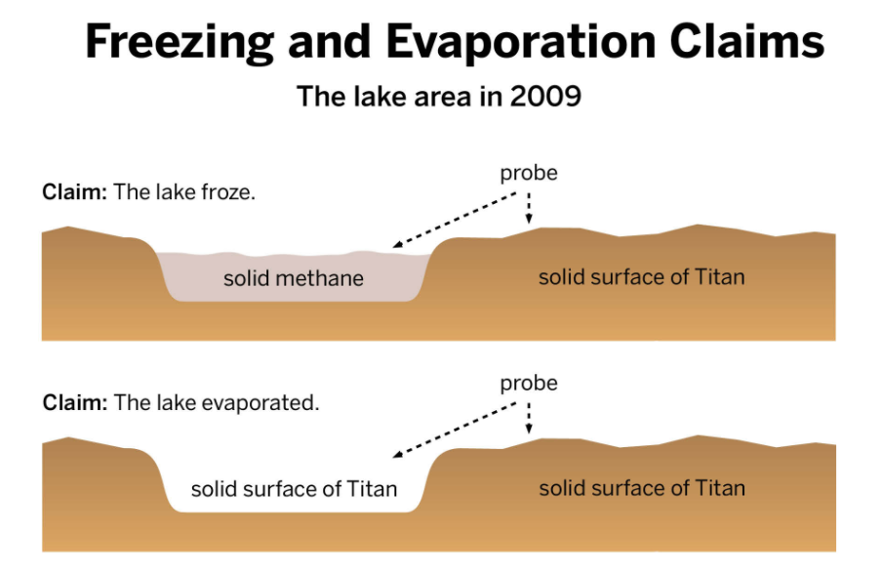

The Lake Froze

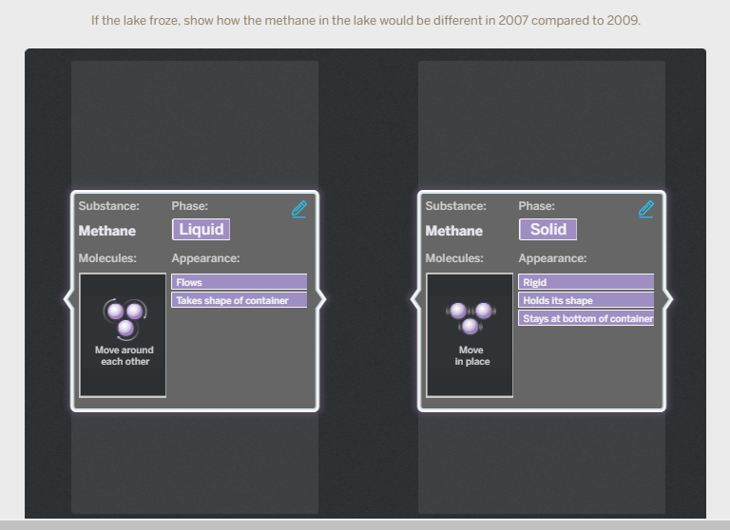

The Lake Evaporated

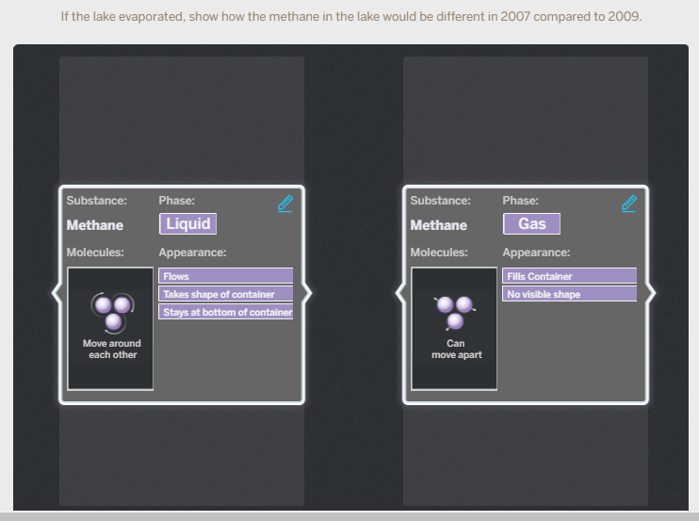

Writing About the Titan Claims

Name __________________

In class, you created two models of the molecular scale: one showing evaporation and the other

freezing. Now, you will write an explanation of your models. The models are on the back of the paper. Then, use the word bank below to complete your response.

**Word Bank: Freedom of Movement, gas, macro scale, liquid, molecular scale, solid**

**____________________________________________________________________________**

____________________________________________________________________________

**____________________________________________________________________________**

____________________________________________________________________________

**____________________________________________________________________________**

____________________________________________________________________________

**____________________________________________________________________________**

____________________________________________________________________________

**____________________________________________________________________________**

____________________________________________________________________________

**____________________________________________________________________________**

____________________________________________________________________________

**____________________________________________________________________________**

____________________________________________________________________________

**____________________________________________________________________________**

____________________________________________________________________________